Division(s): N/A

ITEM PF6E

PENSION FUND COMMITTEE – 25 NOVEMBER 2005

OVERVIEW AND OUTLOOK FOR THE INVESTMENT MARKETS

Report by the Independent Financial Adviser

- Economic growth in the developed western economies has declined from the cyclical peak in 2004 as the figures for gross domestic product (GDP) show.

 | % growth
 | 2002 | 2003 | 2004 | Consensus  2005 | Forecasts  2006
UK | 1.8 | 2.2 | 3.2 | 2.0 | 2.2
USA | 1.9 | 3.0 | 4.4 | 3.6 | 3.0
Eurozone | 0.9 | 0.5 | 1.8 | 1.3 | 1.5
Japan | -0.3 | 1.4 | 2.9 | 1.5 | 1.5

- The estimate for UK growth in 2005 is probably still too high and may prove to be nearer 1.7% and, with the consumer retrenching because of low growth in real incomes and high debts, that for 2006 may well need trimming to closer to 2.0%, which would again be below trend.

While the USA may achieve 3.6% in 2005, the estimate of 3.0% for 2006 could prove too high in view of rising interest rates and continuing high oil prices, not to mention other negatives. Recent strong data from the Eurozone may indicate that growth will be stronger than forecast in both 2005 and 2006, while the recovery in Japan in both personal consumption and corporate investment could well result in growth of over 2.0% in both 2005 and 2006. Growth in China is expected to continue in the region of 7.5% to 8.5%.

- Oil prices have doubled since the beginning of 2004 as the chart below shows:

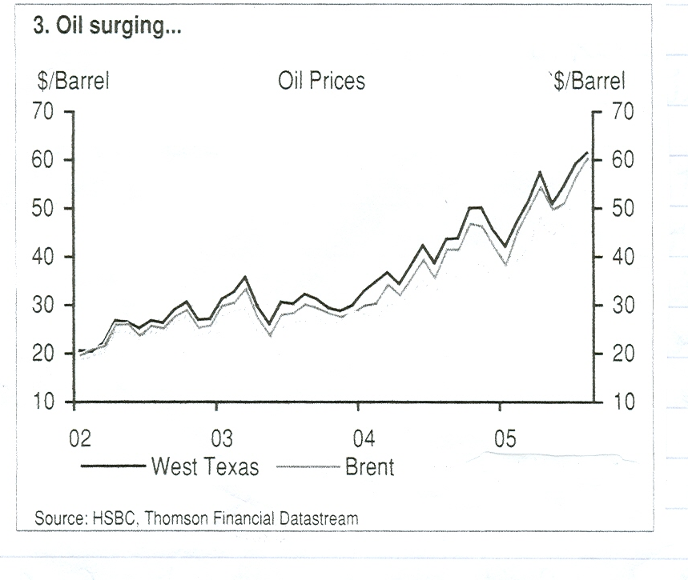
The longer our prices remain at the current high levels there will be an increasing negative impact. Economic growth will be reduced by the transfer of resources to oil producers and inflation will rise. In the UK the consumer price index has now reached 2.4% against the monetary policy target of 2.0%, while in the USA headline inflation rose to 3.8% in the year to September. Even in the Eurozone inflation is comfortably above their target of 2.0%. With most central banks targeting inflation either officially or unofficially, interest rates will tend to harden. The UK monetary policy committee, having reduced short term interest rates by ¼% to 4.5% in August, could now wait until well into next year before considering a further reduction. US short term interest rates, which were 1.0% in June 2004, have been lifted in ¼% steps to the current 4.0%, could be raised to at least 4.5%, which would be neutral in policy impact, or even 5.0%. The Eurozone, which has held rates at 2.0% since June 2003 and was previously hoped to reduce rates because of slow economic growth, may lift them modestly by early 2006. While in Japan, where interest rates have been held at zero while it has suffered deflation, could if inflation returns next year, consider moving to positive interest rates.

- There are other challenges facing monetary policy makers. House prices are at inflated levels, not just in the UK but also in the USA and some European countries such as Germany. In the UK prices have stalled and could decline, whereas elsewhere they are still rising. Budget deficits are at record levels in virtually every developed country and need to be reined back so they do not crowd out the private sector or add to inflationary pressures, while the US balance of payments current account deficit remains huge and sometime the problem has to be addressed.

Markets

- In spite of slowing economic growth, firm or rising interest rates and other problems equity markets have continued to climb the wall of worry, driven by ample monetary liquidity and rising corporate cash and profits from balance sheet restructuring, low real investment and cost cutting. There has been a setback, or consolidation, in October following three months of rising prices. Seasonably October is frequently a treacherous month in the markets, but it is usually followed by a firm November and December to end the year and this bodes to be so this year with a growing number of bids, in cash rather than shares, coupled with a rising participation of the private investor. However, the bull market in the UK and Europe since the low of March 2003 will by the end of this year be 2¾ years old, which is far longer than the average, while a rising number of bids and increasing private sector participation often occur towards market peaks. By the end of this year the market may have to face the reality rather than just the prospect of many of its current worries. The UK equity market is not expensive on a prospective 2006 price earnings ratio of around 13, which should limit the downside, but it will not have the support of the bond market, which could then also be in retreat, with yields rising. Similarly European equities are not expensive, also on a prospective 2006 price earnings ratio of around 13, but they also could encounter softness in the early months of next year. Although economic growth seems to remain strong in the US and corporate profit growth has been good, the equity market is still relatively expensive for this stage of the cycle with a prospective price earnings ratio of around 16 for 2006. Further rises in interest rates and possibly in bond yields will make it more expensive on other ratios, so it could encounter weakness in the first part of next year. The Japanese equity market is relatively uncorrelated to those in the western world and there are several positive factors that could push the market higher in the medium term. The reforming Prime Minister Koizumi has recently been re-elected, this time with an overall majority in the lower house, having ousted many of the non-reformist old guard. The bad loans of the banking system are no longer a problem. Companies have restructured, cutting costs and they are now ready to increase investment and take on more workers. As a result confidence is rising, consumer expenditure is beginning to increase and city land prices, which had fallen by up to 80%, have not just steadied, but turned upwards.

- The enigma of low bond yields continues as the table below shows.

 | UK  % | US  % | Germany  %
10 year Government Benchmark yields | 4.4 | 4.6 | 3.5
Less: inflation | 2.4 | 3.8 | 2.3*
Real (ie inflation adjusted) interest rates | 2.0 | 0.8 | 1.2
* Eurozone consumer price index

The UK Government 50 year index linked bond currently has a real yield of only 1%.

Money in non-inflationary conditions is expected to earn at least 2.5% if not more, so it can be seen from the above that nominal yields are far too low. This is surprising with all government budgets in large deficit to be financed by huge sales of Government Bonds, but this seems to be offset by institutions and pension funds shifting their asset mix from equities to bonds. The trend cannot go on forever and sooner or later reality must dawn, particularly with short term rates rising in the USA.

- Commercial property has been a very strong market in the last two or three years, and particularly so in the last year with total returns (net rental income plus capital appreciation) in the range of 15% for offices to 20% for retail space. As a result yields have declined from the 6% to 8% range for the last ten years to as low as 4% in some cases. Several property funds, particularly those open to retail investors, have closed to new subscriptions, because they cannot find prime property at the right price. The immediate outlook for commercial property is probably dull at best.

- The US dollar remains firm supported by rising interest rates and strong economic growth, even though the balance of payments continues in heavy deficit. Sterling has fallen from a high of $1.94 to the current $1.74 and against the euro from euro 0.72 to euro 0.68. Even so sterling is being supported by interest rates higher than those of other countries and by its status as an oil and gas producer.

However, longer term these supports will weaken as interest rates abroad rise relative to the UK and declining oil and gas production requires increased energy imports. Our current account deficit will then weigh more heavily on the exchange rate and sterling could weaken, initially towards £1.65 and euro 0.65 and against the yen to a range of yen 165-180 from the current yen 205.

- Charts of stock markets and currencies are attached.

AF BUSHELL
Independent Financial Adviser

November 2005


